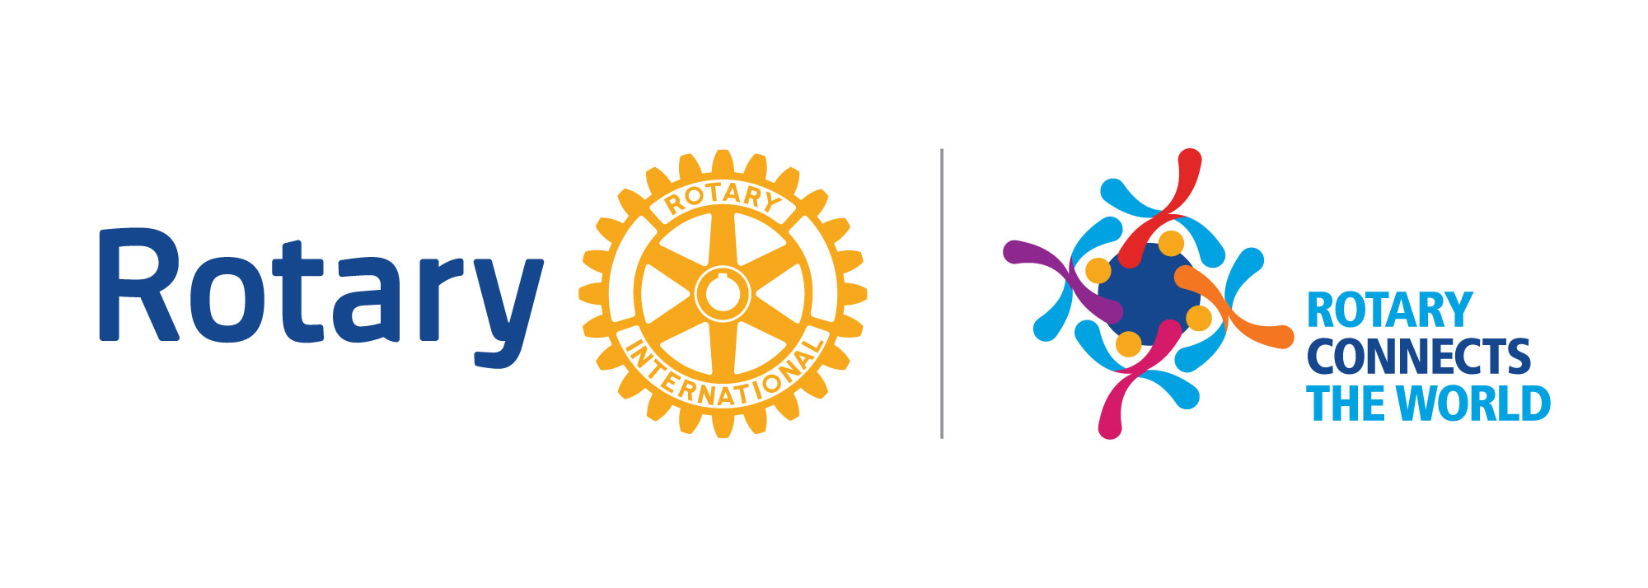
Sponsorship Information Form
Rotary District 7545
Annual Conference
“Celebrating Our Clubs”
Stonewall Resort
May 1-3, 2020

Thank you for your financial support of the Rotary District 7545 Annual Conference. The fifty-five clubs in our district work year-round to support programs in your community, as well as international humanitarian projects. Our Annual District Conference gives our clubs a chance to celebrate their successes, engage in community service, and exchange ideas for future projects. Sponsoring this conference provides your business/organization with the opportunity to promote your brand to Rotarians from all over the State of West Virginia. Your support of our Annual District Conference is appreciated.

Sponsor Name |  | Company Name (if applicable)
Preferred phone:  ( ) |  | Mobile phone:  ( )
Address

Email address:

City | State |  | Zip
Affiliated with a Rotary Club? | ◻ Yes ◻ No    |  | If yes, which club?

Contributions can be made to Rotary District 7545 with District Conference on the memo line and addressed to:

Dennis Shreve, District Treasurer
117 Vermont Avenue
Clarksburg, WV 26301

Please send an electronic version of your logo to our Conference Chair:
Amanda Ream, executivedirector@southcharlestonchamber.org.

Sponsorship Information Form
Rotary District 7545 Annual Conference
“Celebrating Our Clubs”
Stonewall Resort
May 1-3, 2020

Sponsorship Levels:

Please select your desired level or other contribution:

◻ Food Packaging Event Sponsor: $3000

During the conference, attendees will participate in a Food Packaging event, where food will be packaged and sent home with our Rotarians to distribute to those in need in their local communities. Our Food Packaging Event Sponsor will be listed as the sole sponsor for this community service project taking place during the conference. This sponsor receives complimentary lodging and registration for one person for the District Conference. This sponsor also receives advertising in the official conference program and on signage throughout the conference venue, as well as promotion on the Rotary District 7545 website and social media pages. This sponsor will be included in any press releases sent to the media in regard to the Food Packaging community service event.

◻ Platinum Level: $2500

Sponsors at the Platinum level receive complimentary lodging and registration for one person for the District Conference. These sponsors also receive advertising in the official conference program and on signage throughout the conference venue, as well as promotion on the Rotary District 7545 website and social media pages.

◻ Gold Level: $1000

Sponsors at the Gold Level receive complimentary registration for one person for the District Conference. These sponsors also receive advertising in the official conference program and on signage throughout the conference venue, as well as promotion on the Rotary District 7545 website and social media pages.

◻ Silver Level: $500

Sponsors at the Silver Level receive recognition in the official conference program, as well as promotion on the Rotary District 7545 website and social media pages.

◻ Bronze Level: $250

Sponsors at Bronze Level receive recognition in the official conference program.

